**Explore the data**

Our modeling goal here is to understand what kind of songs are more highly rated by music critics in the [#TidyTuesday dataset](https://github.com/rfordatascience/tidytuesday/blob/master/data/2020/2020-04-14/readme.md) on hip hop songs. We’ll use principal component analysis and audio features available in the Spotify API to do this! 🎵

First, let’s look at the data on the rankings.

library(tidyverse)

rankings <- read_csv("https://raw.githubusercontent.com/rfordatascience/tidytuesday/master/data/2020/2020-04-14/rankings.csv")

rankings

## # A tibble: 311 x 12

## ID title artist year gender points n n1 n2 n3 n4 n5

## <dbl> <chr> <chr> <dbl> <chr> <dbl> <dbl> <dbl> <dbl> <dbl> <dbl> <dbl>

## 1 1 Juicy The No… 1994 male 140 18 9 3 3 1 2

## 2 2 Fight … Public… 1989 male 100 11 7 3 1 0 0

## 3 3 Shook … Mobb D… 1995 male 94 13 4 5 1 1 2

## 4 4 The Me… Grandm… 1982 male 90 14 5 3 1 0 5

## 5 5 Nuthin… Dr Dre… 1992 male 84 14 2 4 2 4 2

## 6 6 C.R.E.… Wu-Tan… 1993 male 62 10 3 1 1 4 1

## 7 7 93 ’Ti… Souls … 1993 male 50 7 2 2 2 0 1

## 8 8 Passin… The Ph… 1992 male 48 6 3 2 0 0 1

## 9 9 N.Y. S… Nas 1994 male 46 7 1 3 1 1 1

## 10 10 Dear M… 2Pac 1995 male 42 6 2 1 1 2 0

## # … with 301 more rows

As a first step, let’s recreate the plot, but adjusted a bit.

rankings %>%

ggplot(aes(year, points, color = gender)) +

geom_jitter(alpha = 0.7) +

scale_y_log10() +

labs(

y = "Critic rating",

x = NULL,

color = NULL

)

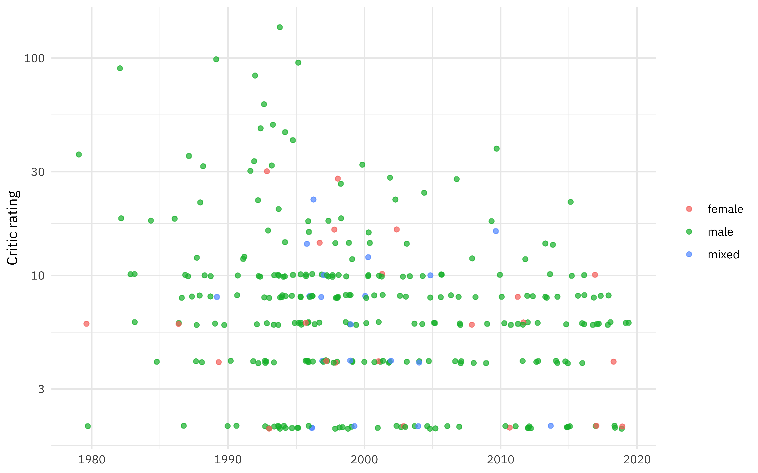

**Get audio features**

library(spotifyr)

access_token <- get_spotify_access_token()

playlist_features <- get_playlist_audio_features("tmock1923", "7esD007S7kzeSwVtcH9GFe")

playlist_features

## # A tibble: 250 x 61

## playlist_id playlist_name playlist_img playlist_owner_… playlist_owner_…

## <chr> <chr> <chr> <chr> <chr>

## 1 7esD007S7k… Top 250 Hiph… https://mos… tmock1923 tmock1923

## 2 7esD007S7k… Top 250 Hiph… https://mos… tmock1923 tmock1923

## 3 7esD007S7k… Top 250 Hiph… https://mos… tmock1923 tmock1923

## 4 7esD007S7k… Top 250 Hiph… https://mos… tmock1923 tmock1923

## 5 7esD007S7k… Top 250 Hiph… https://mos… tmock1923 tmock1923

## 6 7esD007S7k… Top 250 Hiph… https://mos… tmock1923 tmock1923

## 7 7esD007S7k… Top 250 Hiph… https://mos… tmock1923 tmock1923

## 8 7esD007S7k… Top 250 Hiph… https://mos… tmock1923 tmock1923

## 9 7esD007S7k… Top 250 Hiph… https://mos… tmock1923 tmock1923

## 10 7esD007S7k… Top 250 Hiph… https://mos… tmock1923 tmock1923

## # … with 240 more rows, and 56 more variables: danceability <dbl>,

## # energy <dbl>, key <int>, loudness <dbl>, mode <int>, speechiness <dbl>,

## # acousticness <dbl>, instrumentalness <dbl>, liveness <dbl>, valence <dbl>,

## # tempo <dbl>, track.id <chr>, analysis_url <chr>, time_signature <int>,

## # added_at <chr>, is_local <lgl>, primary_color <lgl>, added_by.href <chr>,

## # added_by.id <chr>, added_by.type <chr>, added_by.uri <chr>,

## # added_by.external_urls.spotify <chr>, track.artists <list>,

## # track.available_markets <list>, track.disc_number <int>,

## # track.duration_ms <int>, track.episode <lgl>, track.explicit <lgl>,

## # track.href <chr>, track.is_local <lgl>, track.name <chr>,

## # track.popularity <int>, track.preview_url <chr>, track.track <lgl>,

## # track.track_number <int>, track.type <chr>, track.uri <chr>,

## # track.album.album_type <chr>, track.album.artists <list>,

## # track.album.available_markets <list>, track.album.href <chr>,

## # track.album.id <chr>, track.album.images <list>, track.album.name <chr>,

## # track.album.release_date <chr>, track.album.release_date_precision <chr>,

## # track.album.total_tracks <int>, track.album.type <chr>,

## # track.album.uri <chr>, track.album.external_urls.spotify <chr>,

## # track.external_ids.isrc <chr>, track.external_urls.spotify <chr>,

## # video_thumbnail.url <lgl>, key_name <chr>, mode_name <chr>, key_mode <chr>

This would be perfect for exploring the audio features on their own. On the other hand, this is going to be pretty difficult to match up to the songs in the rankings dataset because both the titles and artists are significantly different, so let’s take a different approach. Let’s create a little function to find the Spotify track identifier via search_spotify() (Spotify has already handled search pretty well) and use purrr::map() to apply it to all the songs we have in our dataset.

pull_id <- function(query) {

search_spotify(query, "track") %>%

arrange(-popularity) %>%

filter(row_number() == 1) %>%

pull(id)

}

ranking_ids <- rankings %>%

mutate(

search_query = paste(title, artist),

search_query = str_to_lower(search_query),

search_query = str_remove(search_query, "ft.*$")

) %>%

mutate(id = map_chr(search_query, possibly(pull_id, NA_character_)))

ranking_ids %>%

select(title, artist, id)

## # A tibble: 311 x 3

## title artist id

## <chr> <chr> <chr>

## 1 Juicy The Notorious B.I.G. 5ByAIlEEnxYdvpnezg7…

## 2 Fight The Power Public Enemy 1yo16b3u0lptm6Cs7lx…

## 3 Shook Ones (Part II) Mobb Deep 4nASzyRbzL5qZQuOPjQ…

## 4 The Message Grandmaster Flash & The Furious … 5DuTNKFEjJIySAyJH1y…

## 5 Nuthin’ But A ‘G’ Tha… Dr Dre ft. Snoop Doggy Dogg 4YtoipFgf4k0AfD17Zf…

## 6 C.R.E.A.M. Wu-Tang Clan 119c93MHjrDLJTApCVG…

## 7 93 ’Til Infinity Souls of Mischief 0PV1TFUMTBrDETzW6KQ…

## 8 Passin’ Me By The Pharcyde 4G3dZN9o3o2X4VKwt4C…

## 9 N.Y. State Of Mind Nas 5zwz05jkQVT68CjUpPw…

## 10 Dear Mama 2Pac 6tDxrq4FxEL2q15y37t…

## # … with 301 more rows

At the end of that, there are 6% of songs that I failed to find a Spotify track identifier for. Not too bad!

Now that we have the track identifiers, we can get the audio features. The function get_track_audio_features() can only take 100 tracks at most at once, so let’s divide up our tracks into smaller chunks and then map() through them.

ranking_features <- ranking_ids %>%

mutate(id_group = row_number() %/% 80) %>%

select(id_group, id) %>%

nest(data = c(id)) %>%

mutate(audio_features = map(data, ~ get_track_audio_features(.$id)))

ranking_features

## # A tibble: 4 x 3

## id_group data audio_features

## <dbl> <list> <list>

## 1 0 <tibble [79 × 1]> <tibble [79 × 18]>

## 2 1 <tibble [80 × 1]> <tibble [80 × 18]>

## 3 2 <tibble [80 × 1]> <tibble [80 × 18]>

## 4 3 <tibble [72 × 1]> <tibble [72 × 18]>

We have audio features! 🎉 Now let’s put that together with the rankings and create a dataframe for modeling.

ranking_df <- ranking_ids %>%

bind_cols(ranking_features %>%

select(audio_features) %>%

unnest(audio_features)) %>%

select(title, artist, points, year, danceability:tempo) %>%

na.omit()

ranking_df

## # A tibble: 293 x 15

## title artist points year danceability energy key loudness mode

## <chr> <chr> <dbl> <dbl> <dbl> <dbl> <int> <dbl> <int>

## 1 Juicy The N… 140 1994 0.889 0.816 9 -4.67 1

## 2 Figh… Publi… 100 1989 0.797 0.582 2 -13.0 1

## 3 Shoo… Mobb … 94 1995 0.637 0.878 6 -5.51 1

## 4 The … Grand… 90 1982 0.947 0.607 10 -10.6 0

## 5 Nuth… Dr Dr… 84 1992 0.801 0.699 11 -8.18 0

## 6 C.R.… Wu-Ta… 62 1993 0.479 0.549 11 -10.6 0

## 7 93 ’… Souls… 50 1993 0.59 0.672 1 -11.8 1

## 8 Pass… The P… 48 1992 0.759 0.756 4 -8.14 0

## 9 N.Y.… Nas 46 1994 0.665 0.91 6 -4.68 0

## 10 Dear… 2Pac 42 1995 0.773 0.54 6 -7.12 1

## # … with 283 more rows, and 6 more variables: speechiness <dbl>,

## # acousticness <dbl>, instrumentalness <dbl>, liveness <dbl>, valence <dbl>,

## # tempo <dbl>

How are these quantities correlated with each other?

library(corrr)

ranking_df %>%

select(year:tempo) %>%

correlate() %>%

rearrange() %>%

shave() %>%

rplot(shape = 15, colours = c("darkorange", "white", "darkcyan")) +

theme_plex()

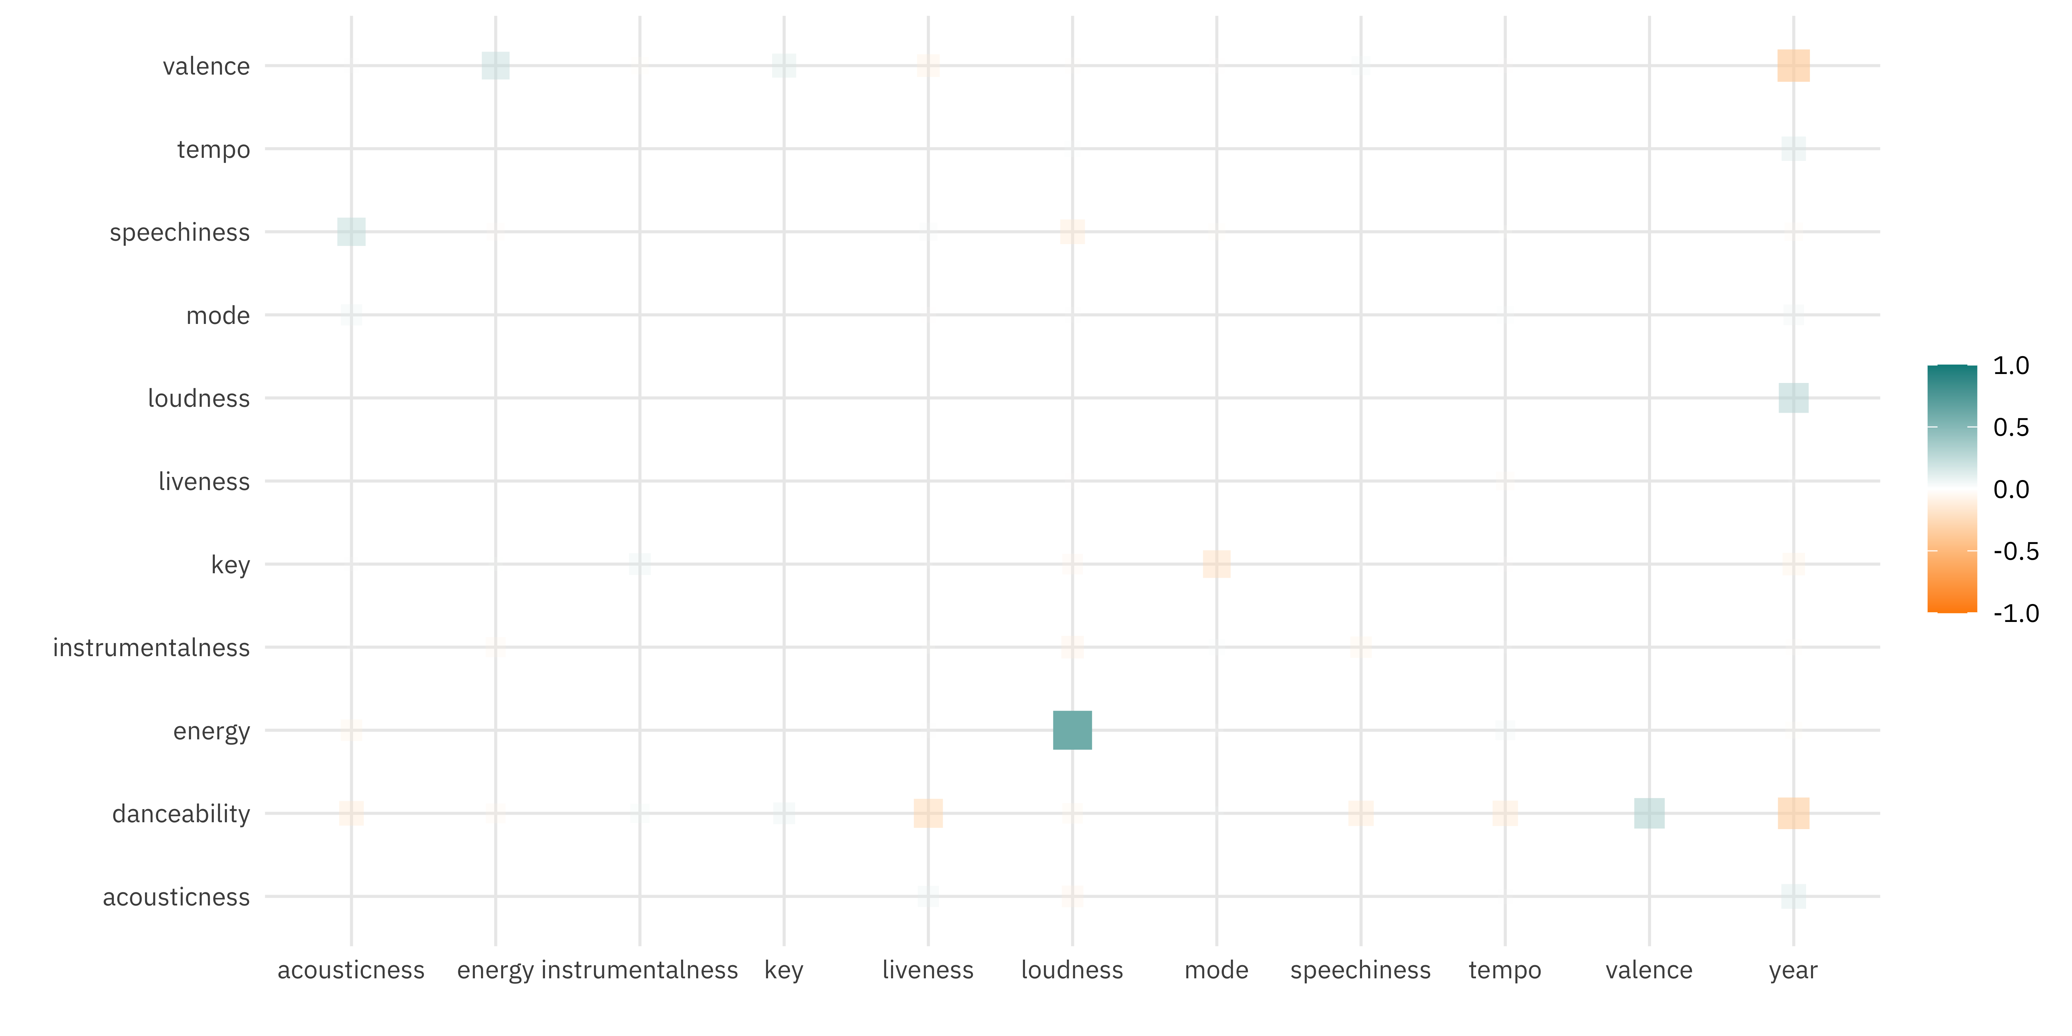

Louder songs have higher energy, and older songs tend to be more danceable and have higher valence (i.e. be more “happy”).

Let’s train a linear model on these audio features.

ranking_lm <- ranking_df %>%

select(-title, -artist) %>%

lm(log(points) ~ ., data = .)

summary(ranking_lm)

##

## Call:

## lm(formula = log(points) ~ ., data = .)

##

## Residuals:

## Min 1Q Median 3Q Max

## -1.68521 -0.58721 0.05728 0.44134 2.63178

##

## Coefficients:

## Estimate Std. Error t value Pr(>|t|)

## (Intercept) 68.2251604 13.9295818 4.898 1.64e-06 ***

## year -0.0329381 0.0068396 -4.816 2.40e-06 ***

## danceability 0.0068425 0.4409221 0.016 0.988

## energy -0.0487288 0.4372164 -0.111 0.911

## key 0.0091604 0.0137126 0.668 0.505

## loudness 0.0360689 0.0226039 1.596 0.112

## mode -0.0690822 0.1041311 -0.663 0.508

## speechiness -0.2697032 0.4118937 -0.655 0.513

## acousticness 0.4754636 0.3003998 1.583 0.115

## instrumentalness -0.6862222 0.8101330 -0.847 0.398

## liveness 0.0811289 0.2604150 0.312 0.756

## valence -0.3930333 0.2859187 -1.375 0.170

## tempo 0.0008642 0.0016334 0.529 0.597

## ---

## Signif. codes: 0 '***' 0.001 '**' 0.01 '*' 0.05 '.' 0.1 ' ' 1

##

## Residual standard error: 0.8288 on 280 degrees of freedom

## Multiple R-squared: 0.09513, Adjusted R-squared: 0.05635

## F-statistic: 2.453 on 12 and 280 DF, p-value: 0.004697

We only have evidence for year being important in the critic ratings from this model. We know that some of the features are at least a bit correlated, though, so let’s use PCA.

**Principal component analysis**

We can use the [recipes](https://tidymodels.github.io/recipes/) package to implement PCA in tidymodels.

library(tidymodels)

ranking_rec <- recipe(points ~ ., data = ranking_df) %>%

update_role(title, artist, new_role = "id") %>%

step_log(points) %>%

step_normalize(all_predictors()) %>%

step_pca(all_predictors())

ranking_prep <- prep(ranking_rec)

ranking_prep

## Data Recipe

##

## Inputs:

##

## role #variables

## id 2

## outcome 1

## predictor 12

##

## Training data contained 293 data points and no missing data.

##

## Operations:

##

## Log transformation on points [trained]

## Centering and scaling for year, danceability, energy, key, loudness, ... [trained]

## PCA extraction with year, danceability, energy, key, loudness, ... [trained]

Let’s walk through the steps in this recipe.

* First, we must tell the recipe() what our model is going to be (using a formula here) and what data we are using.
* Next, we update the role for title and artist, since these are variables we want to keep around for convenience as identifiers for rows but are not a predictor or outcome.
* Next, we take the log of the outcome (points, the critic ratings).
* We need to center and scale the numeric predictors, because we are about to implement PCA.
* Finally, we use step_pca() for the actual principal component analysis.

Before using prep() these steps have been defined but not actually run or implemented. The prep() function is where everything gets evaluated.

Once we have that done, we can both explore the results of the PCA and then eventually use it in a model. Let’s start with checking out how the PCA turned out. We can tidy() any of our recipe steps, including the PCA step, which is the third step. Then let’s make a visualization to see what the components look like.

tidied_pca <- tidy(ranking_prep, 3)

tidied_pca %>%

mutate(component = fct_inorder(component)) %>%

ggplot(aes(value, terms, fill = terms)) +

geom_col(show.legend = FALSE) +

facet_wrap(~component) +

labs(y = NULL)

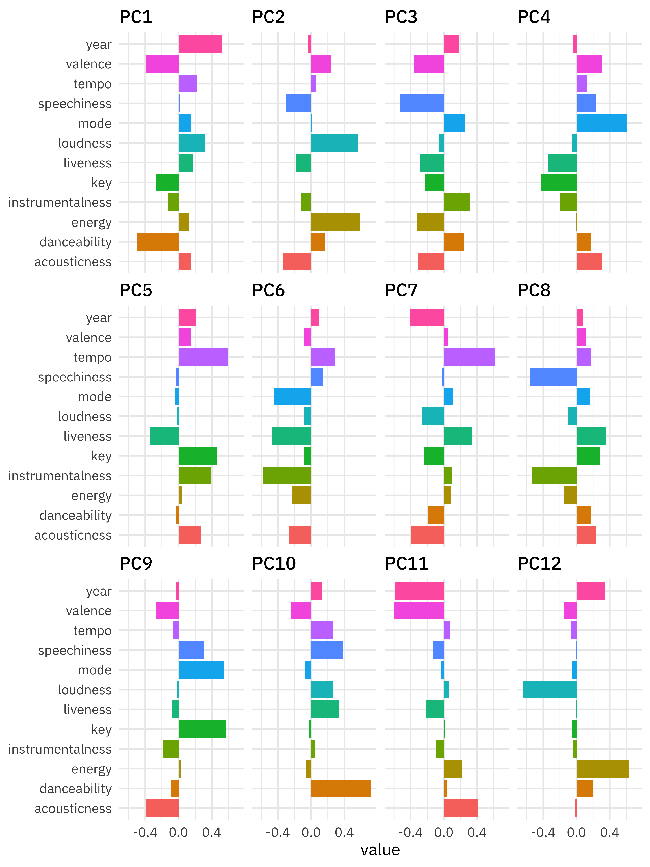

Let’s zoom in on the first four components.

library(tidytext)

tidied_pca %>%

filter(component %in% c("PC1", "PC2", "PC3", "PC4")) %>%

group_by(component) %>%

top_n(6, abs(value)) %>%

ungroup() %>%

mutate(terms = reorder_within(terms, abs(value), component)) %>%

ggplot(aes(abs(value), terms, fill = value > 0)) +

geom_col() +

facet_wrap(~component, scales = "free_y") +

scale_y_reordered() +

labs(

x = "Absolute value of contribution",

y = NULL, fill = "Positive?"

)

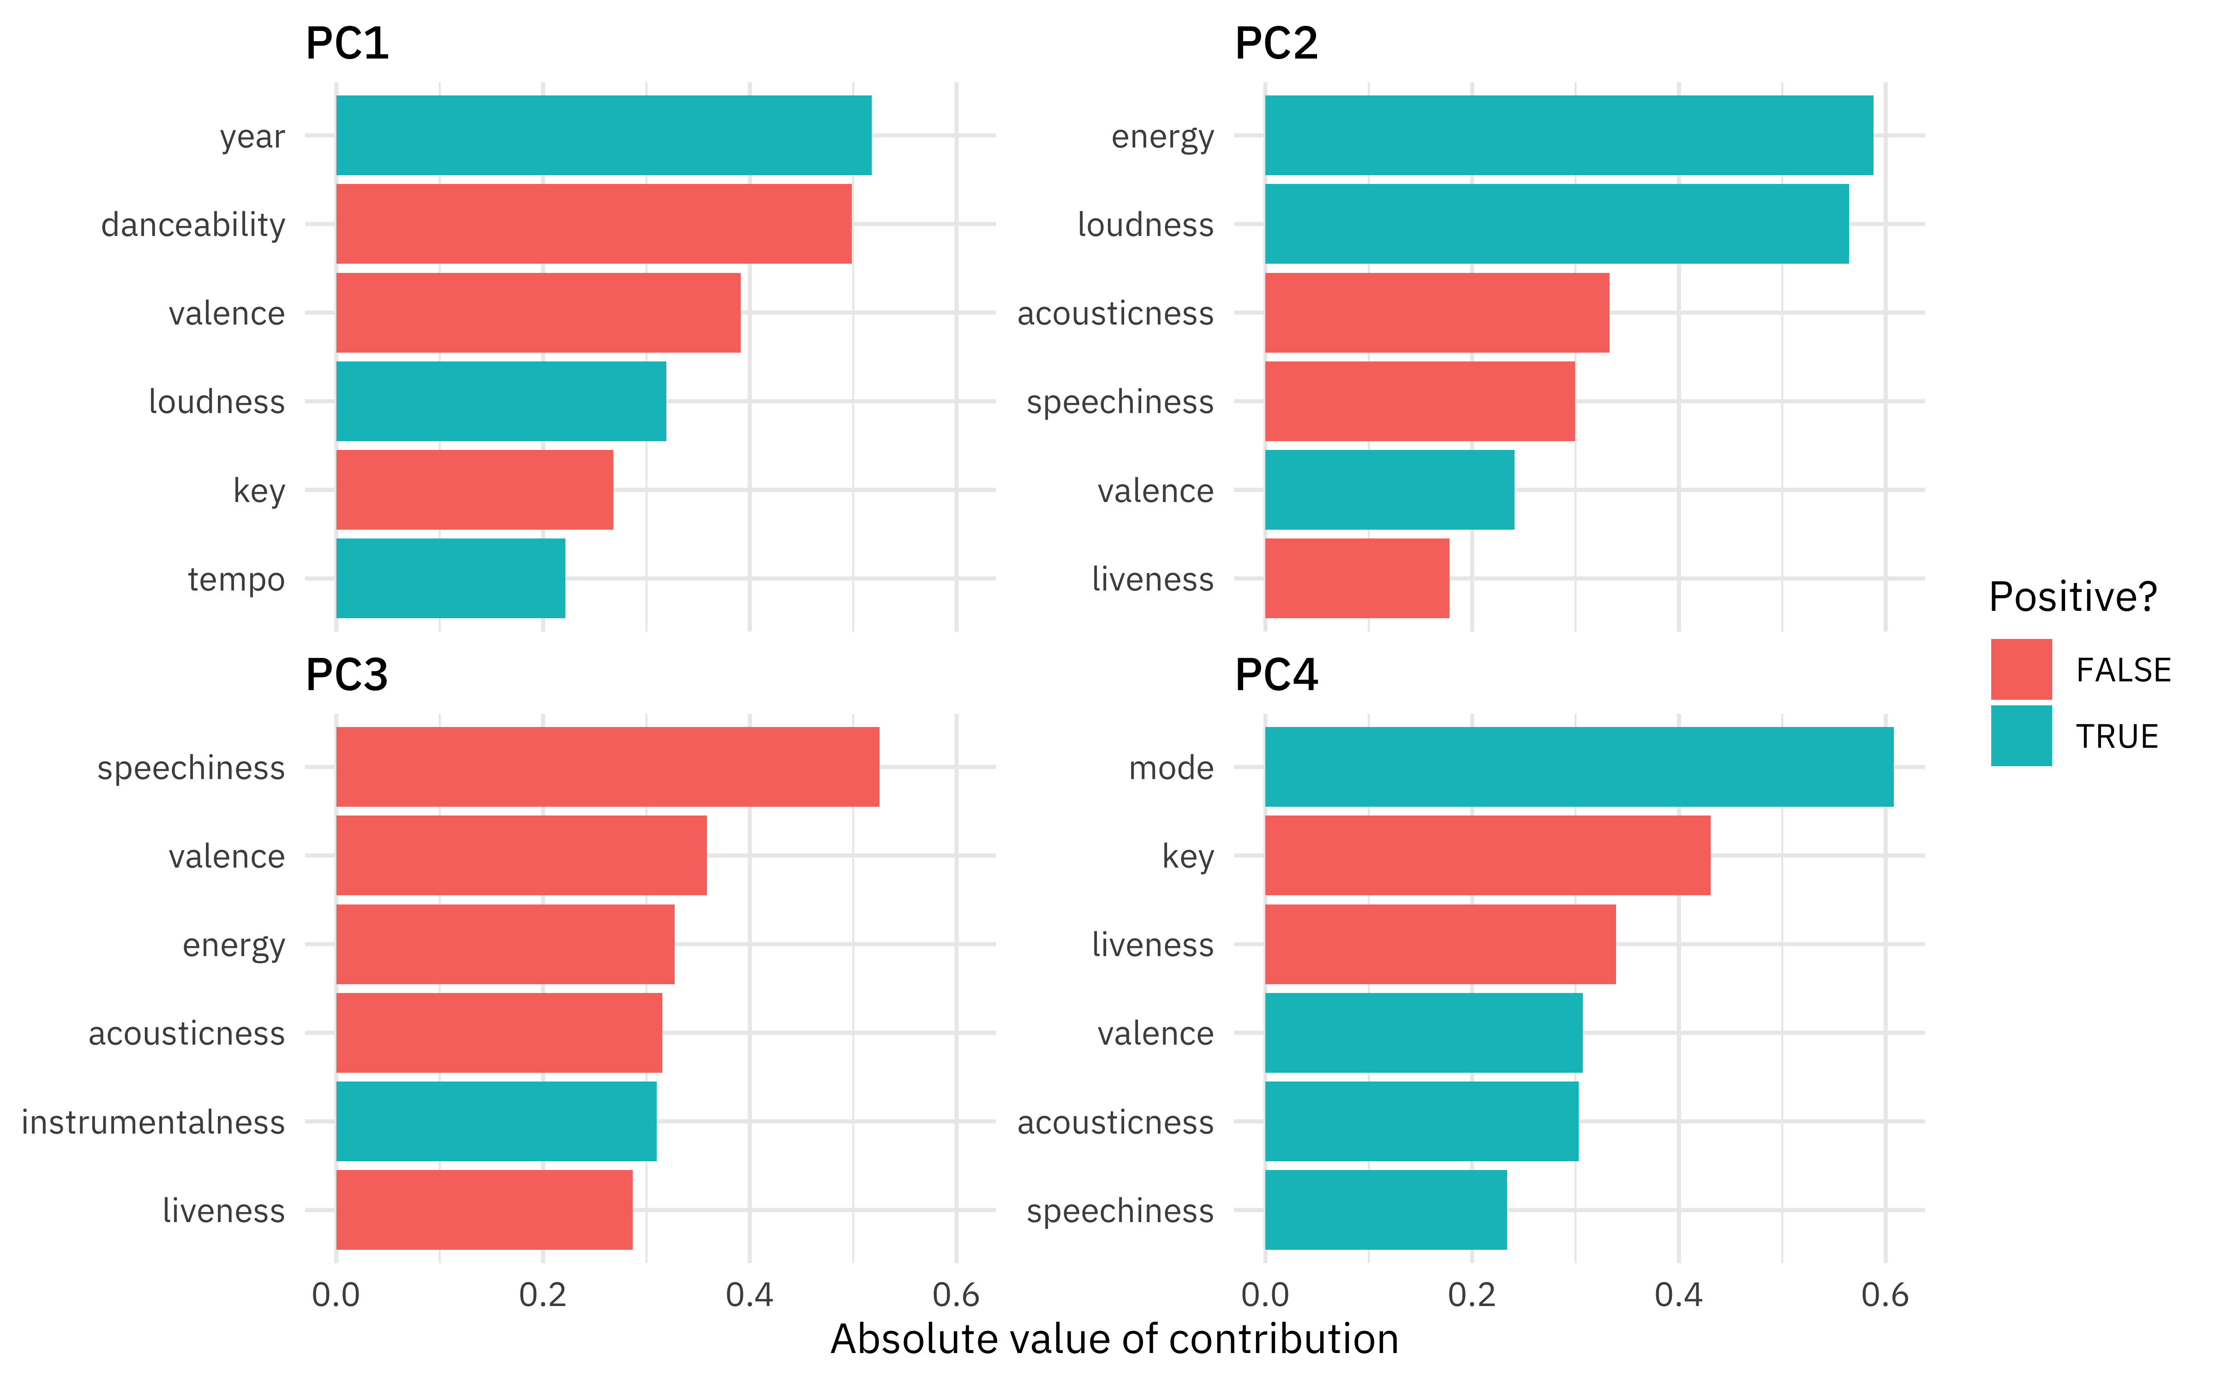

So PC1 is mostly about age and danceability, PC2 is mostly energy and loudness, PC3 is mostly speechiness, and PC4 is about the musical characteristics (actual key and major vs. minor key).

How are the songs distributed in the plane of the first two components?

juice(ranking_prep) %>%

ggplot(aes(PC1, PC2, label = title)) +

geom_point(alpha = 0.2) +

geom_text(check_overlap = TRUE, family = "IBMPlexSans")

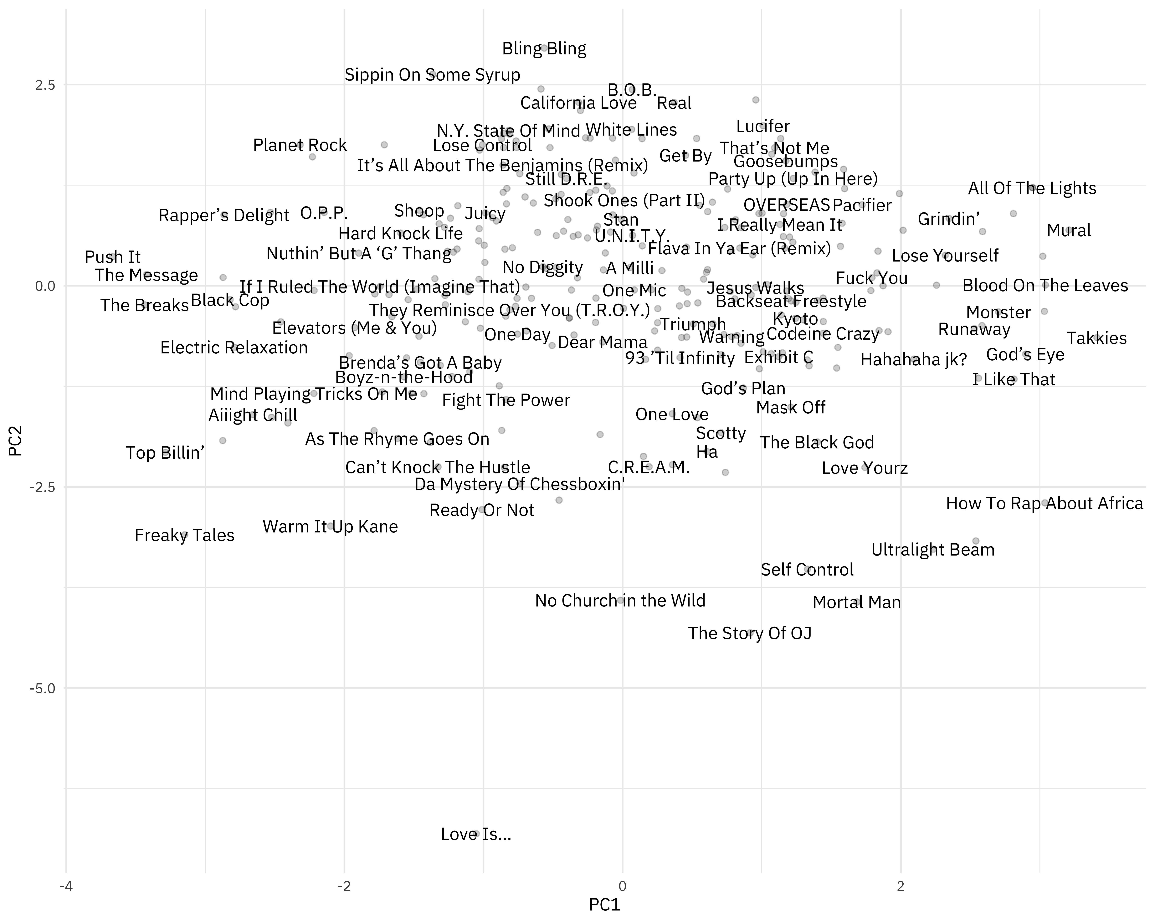

* Older, more danceable songs are to the left.
* Higher energy, louder songs are towards the top.

You can change out PC2 for PC3, for example, to instead see where more “speechy” songs are.

How much variation are we capturing?

sdev <- ranking_prep$steps[[3]]$res$sdev

percent_variation <- sdev^2 / sum(sdev^2)

tibble(

component = unique(tidied_pca$component),

percent_var = percent_variation ## use cumsum() to find cumulative, if you prefer

) %>%

mutate(component = fct_inorder(component)) %>%

ggplot(aes(component, percent_var)) +

geom_col() +

scale_y_continuous(labels = scales::percent_format()) +

labs(x = NULL, y = "Percent variance explained by each PCA component")

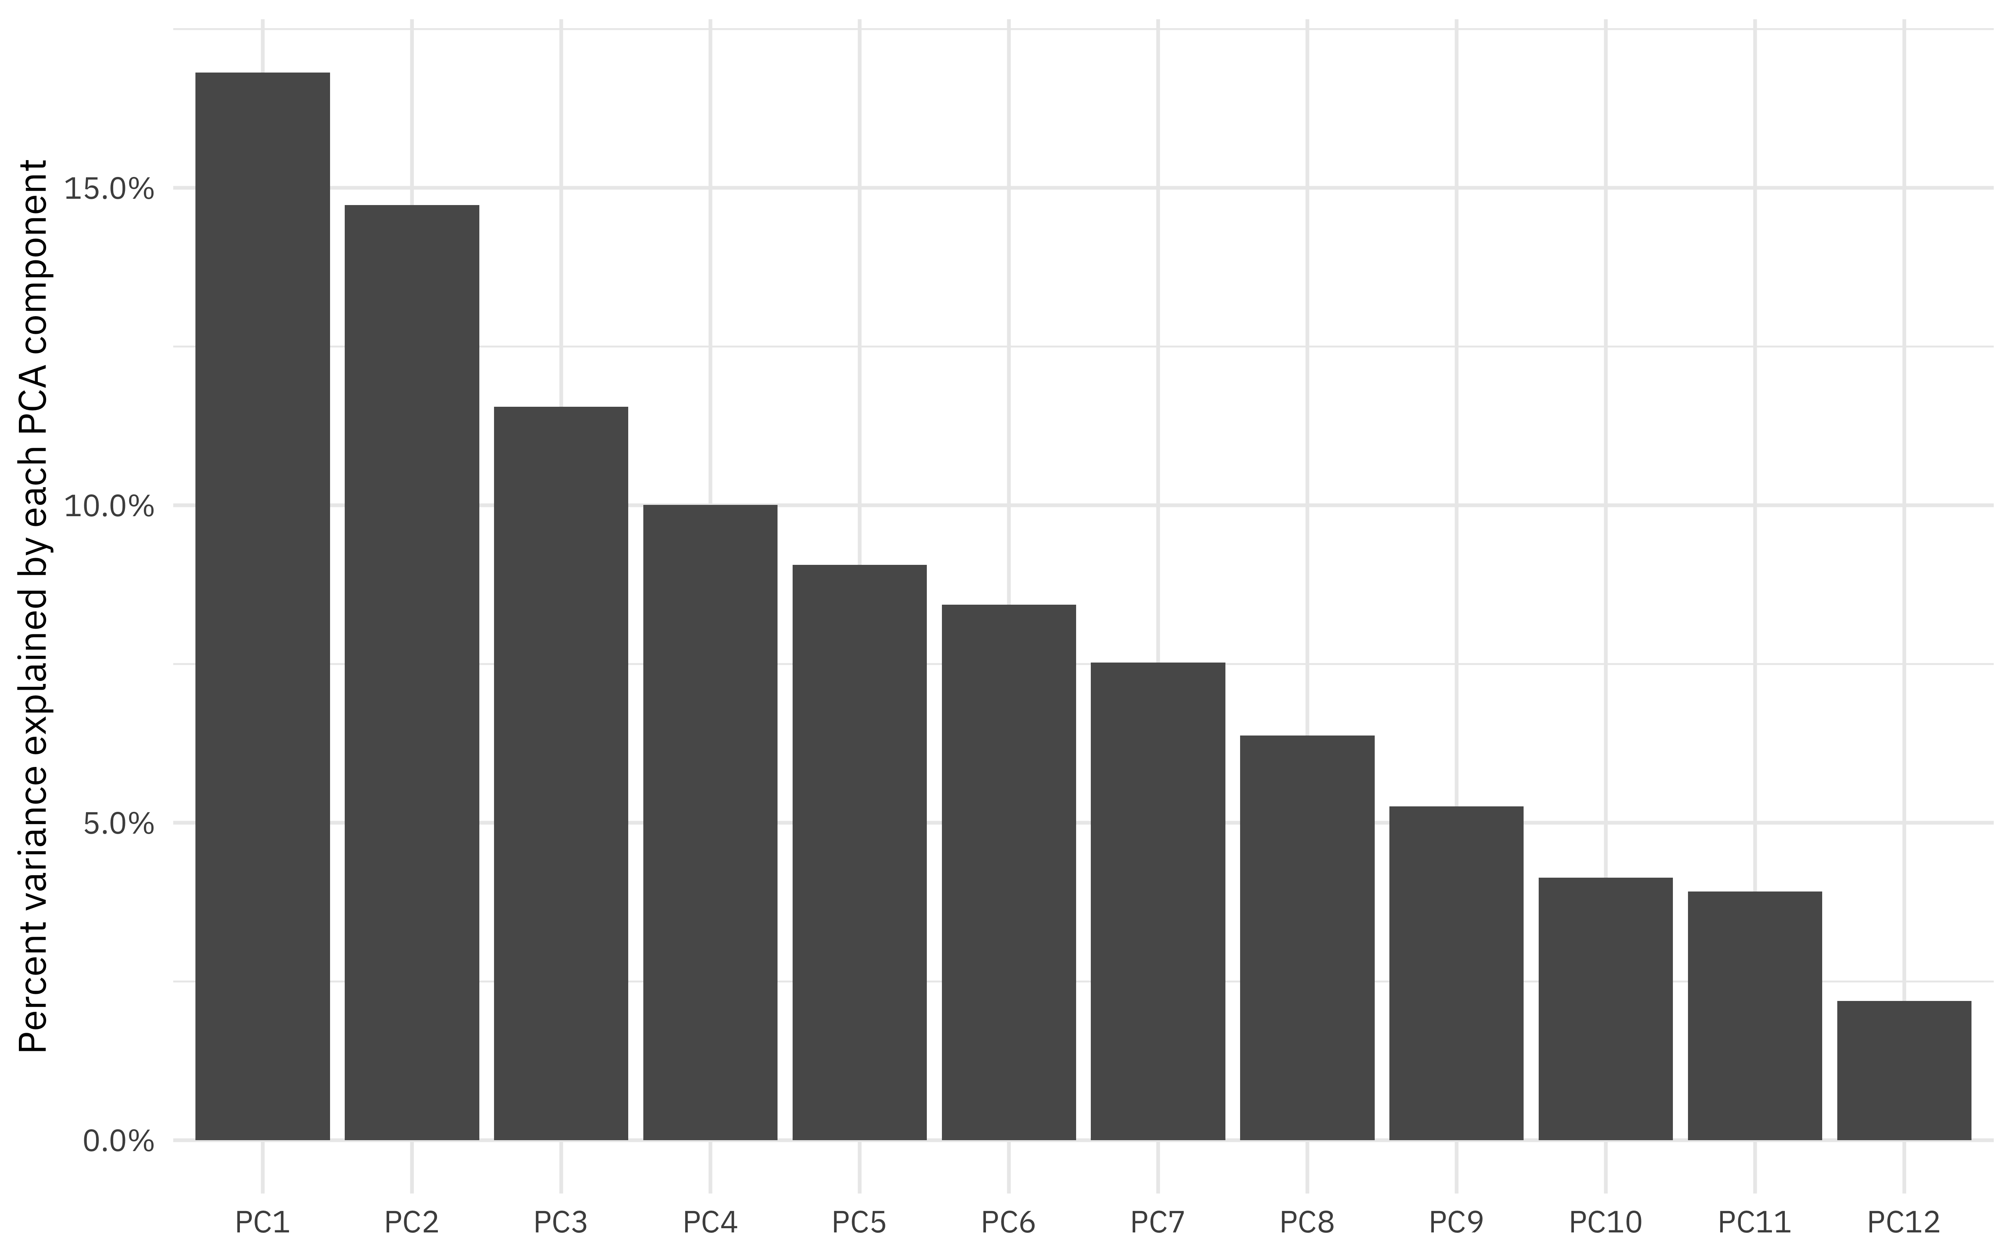

And finally, let’s fit the same kind of model we fit before, but now with juice(ranking_prep). This approach really emphasizes how recipes can be used for data preprocessing. Notice how juice(ranking_prep) has already taken the log of points, has the component values ready to go, etc.

juice(ranking_prep)

## # A tibble: 293 x 8

## title artist points PC1 PC2 PC3 PC4 PC5

## <fct> <fct> <dbl> <dbl> <dbl> <dbl> <dbl> <dbl>

## 1 Juicy The Notorious B.I… 4.94 -0.987 0.904 -1.10 1.16 5.46e-1

## 2 Fight The P… Public Enemy 4.61 -0.837 -1.42 0.686 0.184 -1.78e+0

## 3 Shook Ones … Mobb Deep 4.54 0.0153 1.06 -0.929 0.681 -3.27e-1

## 4 The Message Grandmaster Flash… 4.50 -3.42 0.138 -0.0333 -0.653 -2.63e-4

## 5 Nuthin’ But… Dr Dre ft. Snoop … 4.43 -1.90 0.405 -0.629 -1.18 8.27e-2

## 6 C.R.E.A.M. Wu-Tang Clan 4.13 0.190 -2.25 -1.94 -0.245 2.80e+0

## 7 93 ’Til Inf… Souls of Mischief 3.91 0.413 -0.892 -0.576 1.93 1.20e+0

## 8 Passin’ Me … The Pharcyde 3.87 -0.990 0.289 -0.607 -0.615 -1.01e+0

## 9 N.Y. State … Nas 3.83 -0.819 1.93 -1.41 -0.736 -5.23e-1

## 10 Dear Mama 2Pac 3.74 -0.143 -0.698 1.19 0.349 -4.05e-1

## # … with 283 more rows

pca_fit <- juice(ranking_prep) %>%

select(-title, -artist) %>%

lm(points ~ ., data = .)

summary(pca_fit)

##

## Call:

## lm(formula = points ~ ., data = .)

##

## Residuals:

## Min 1Q Median 3Q Max

## -1.55257 -0.58620 0.04886 0.39583 2.89017

##

## Coefficients:

## Estimate Std. Error t value Pr(>|t|)

## (Intercept) 1.92516 0.04944 38.936 <2e-16 ***

## PC1 -0.07547 0.03487 -2.165 0.0312 *

## PC2 0.03540 0.03725 0.950 0.3428

## PC3 -0.07129 0.04207 -1.695 0.0912 .

## PC4 -0.03100 0.04520 -0.686 0.4934

## PC5 -0.04195 0.04749 -0.883 0.3778

## ---

## Signif. codes: 0 '***' 0.001 '**' 0.01 '*' 0.05 '.' 0.1 ' ' 1

##

## Residual standard error: 0.8463 on 287 degrees of freedom

## Multiple R-squared: 0.03273, Adjusted R-squared: 0.01588

## F-statistic: 1.942 on 5 and 287 DF, p-value: 0.08738